Index.html:

Before:

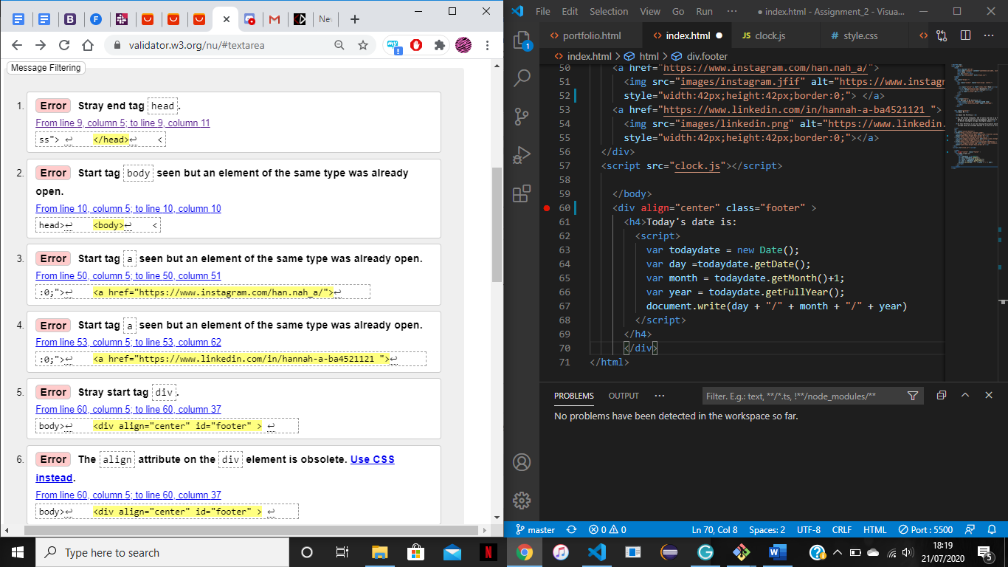After:

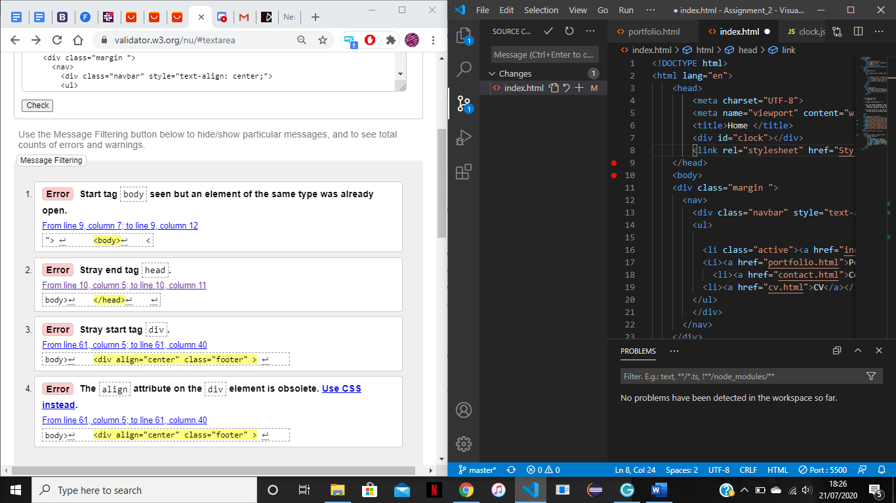

I did not make all the changes that where advices as it was causing issues with my site or when I go to check what was highlighted, I do not see the error. In this case it said I had a stranded div and head tag when I did not and that I have 2 body tags which is not true.

portfolio.html :

Before:

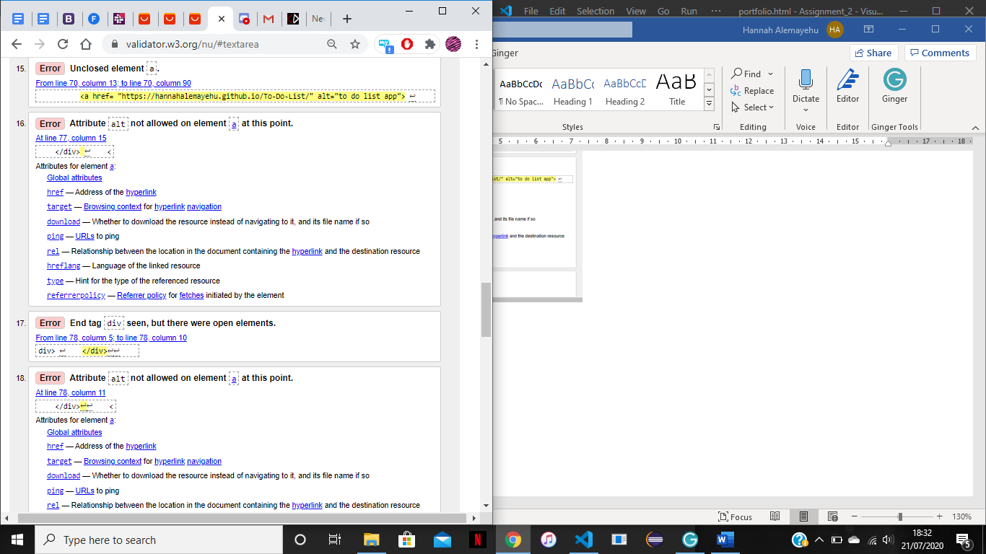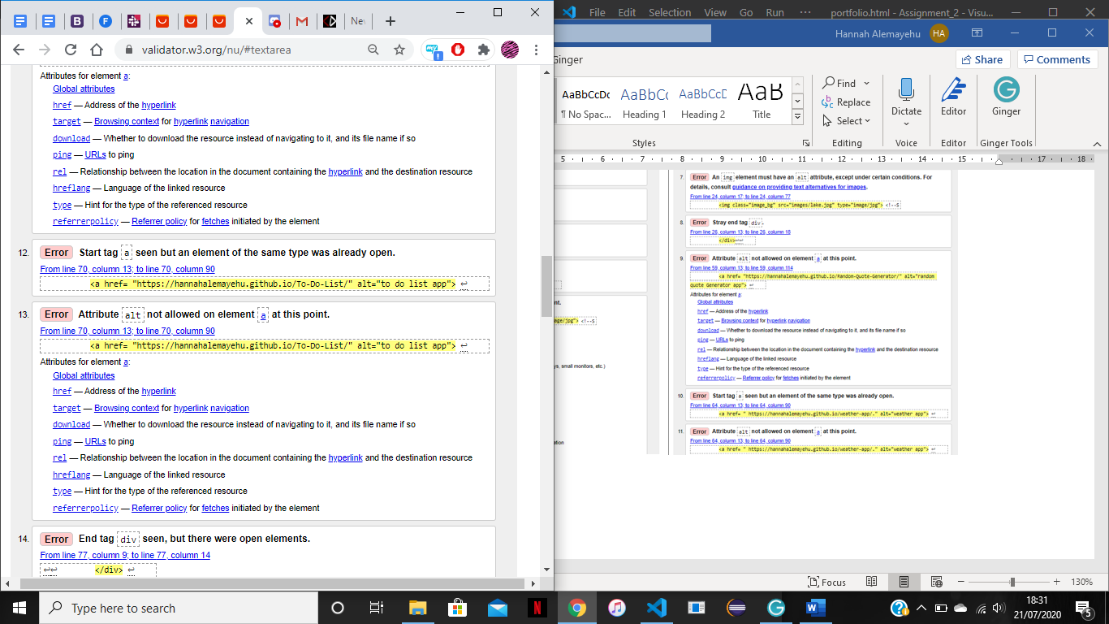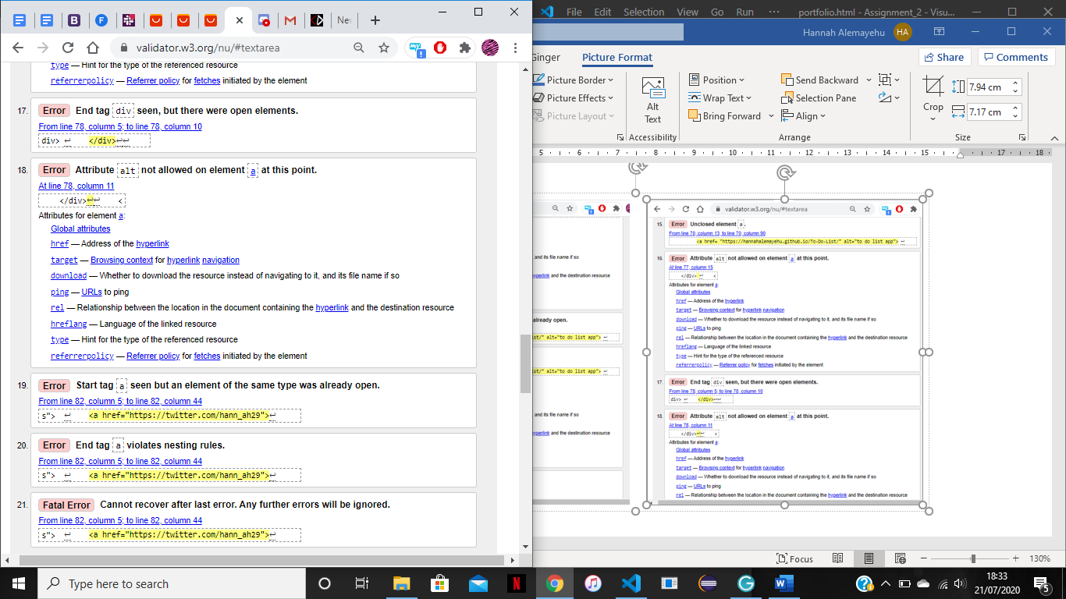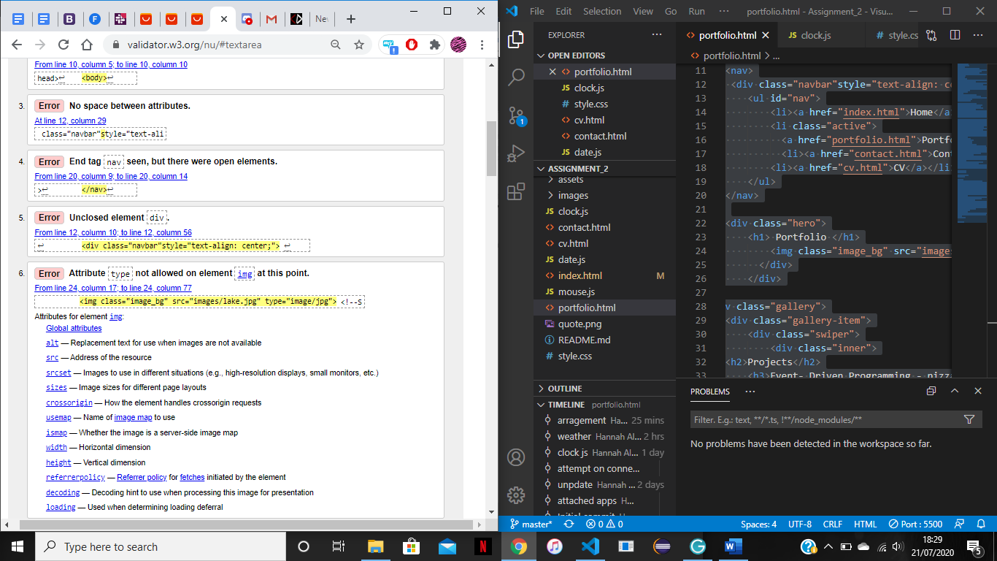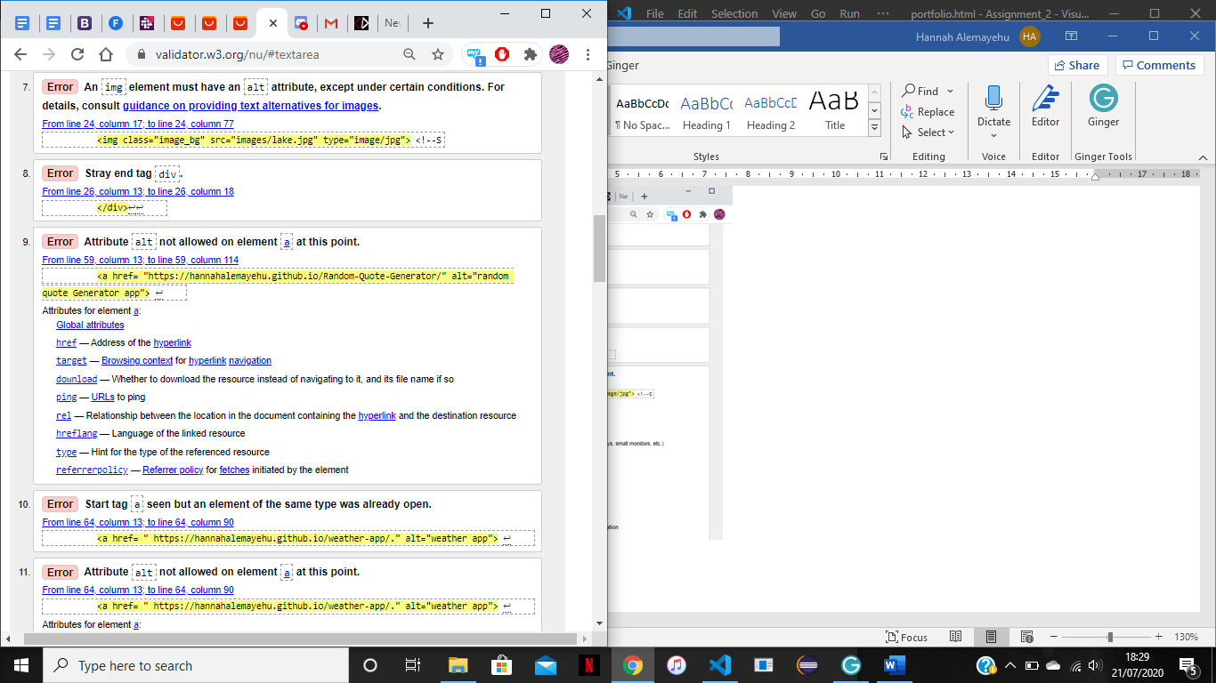

After:

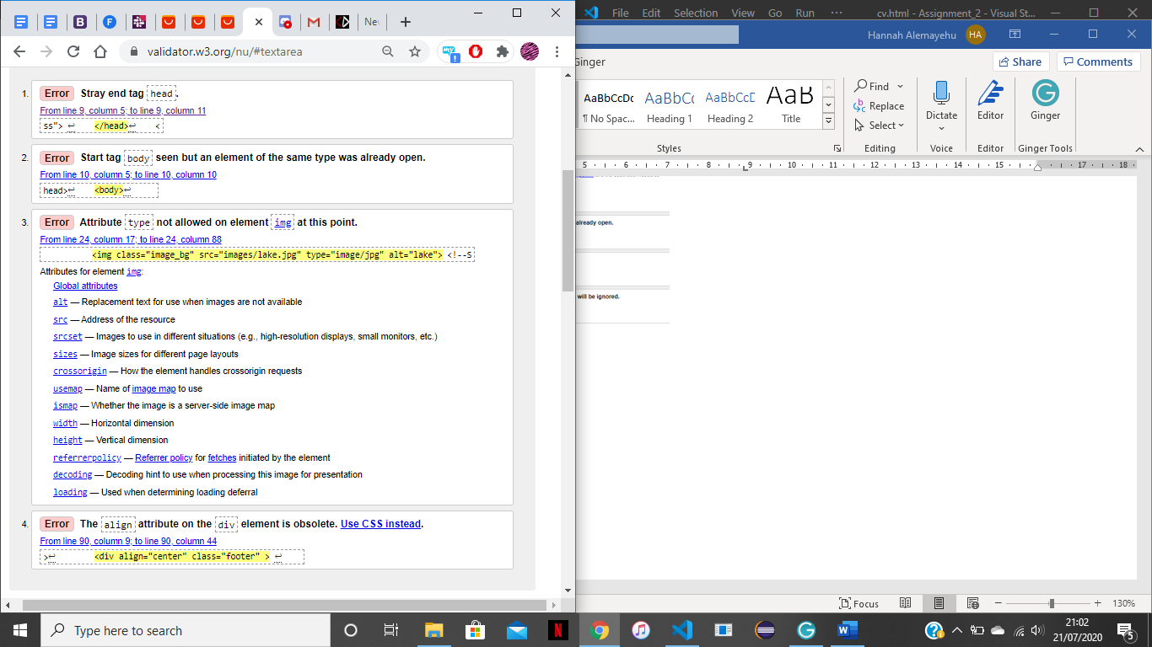

I did not make all the changes that where advices as it was causing issues with my site or when I go to check what was highlighted, I do not see the error. In this case it said I had a stranded head and body tag when I did not.

cv.html:

before:

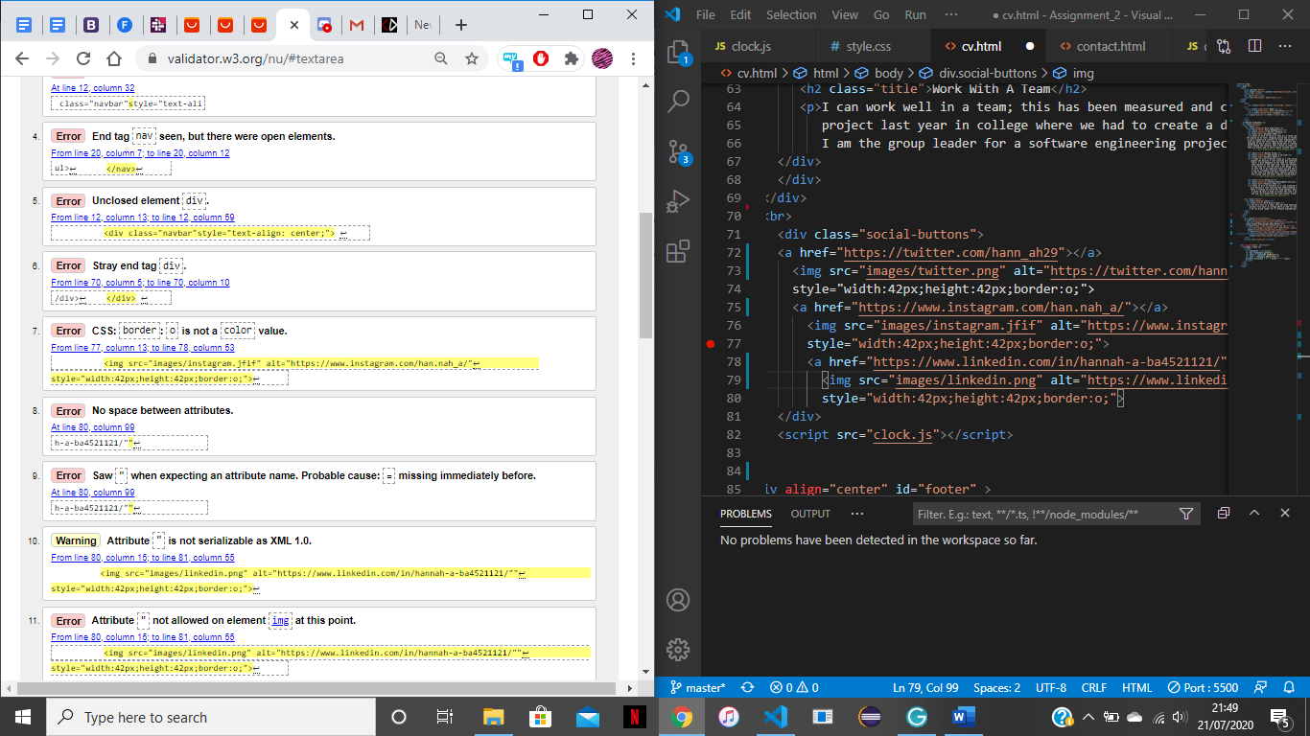

After:

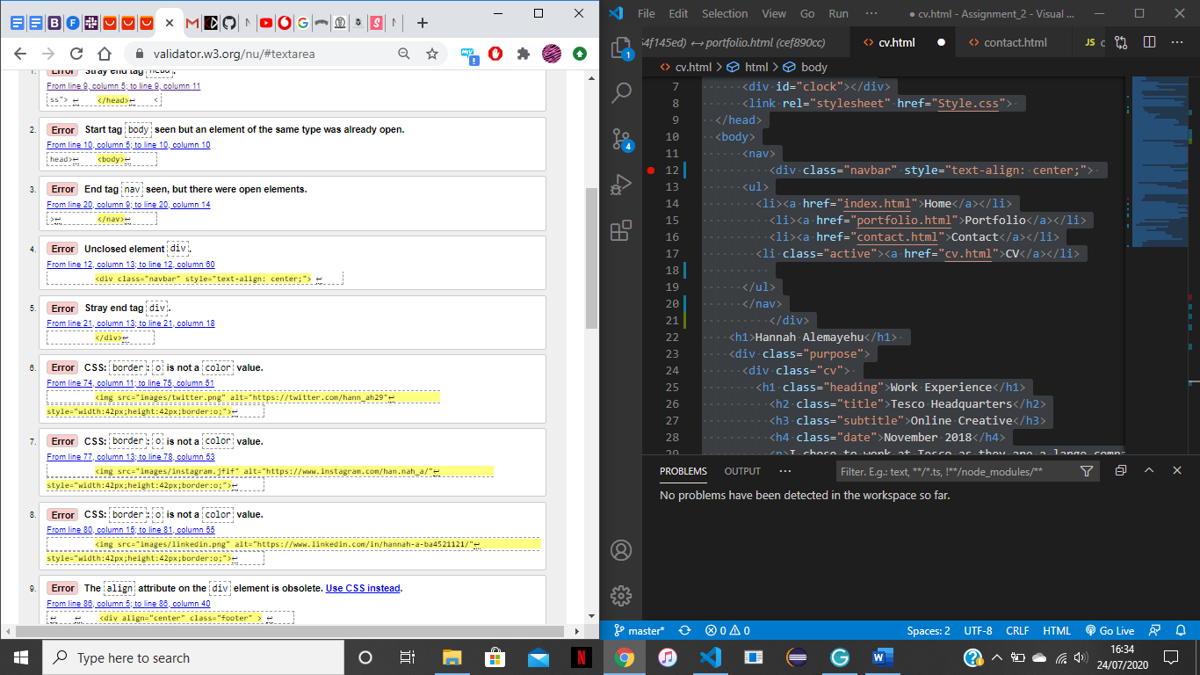

I did not make all the changes that where advices as it was causing issues with my site or when I go to check what was highlighted, I do not see the error. In this case it said I had a stranded div tag when I did not.

Contact.html:

Before:

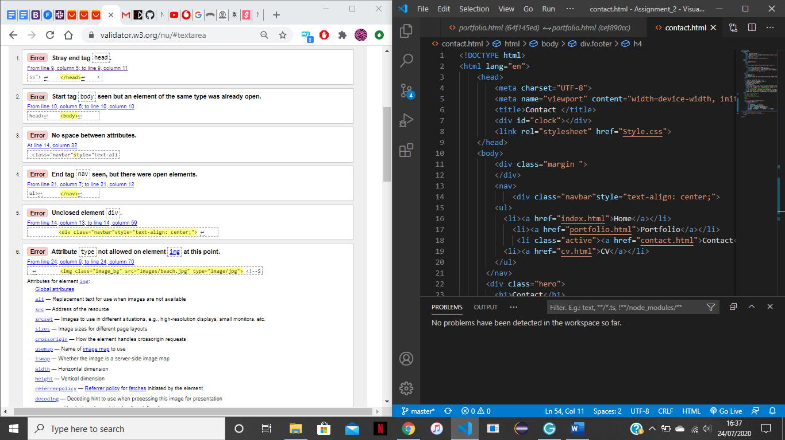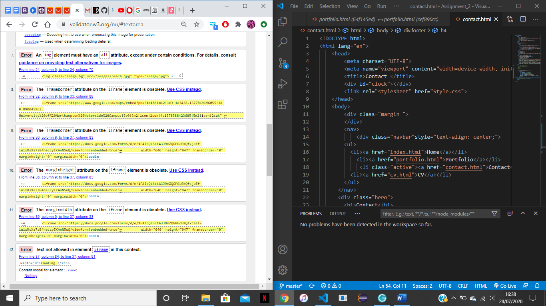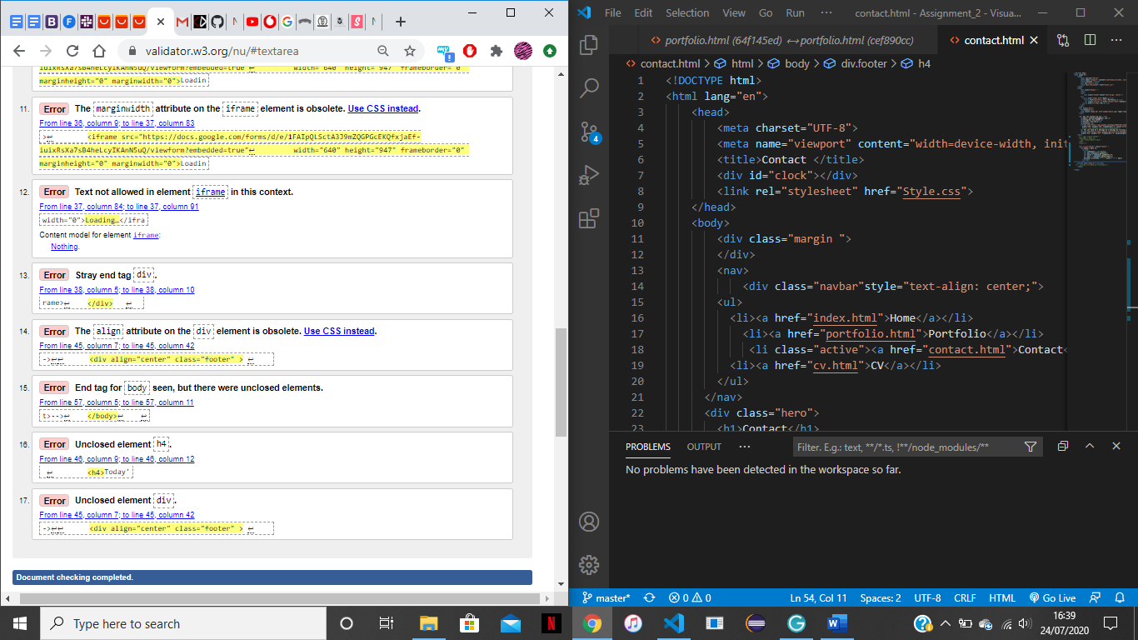

After:

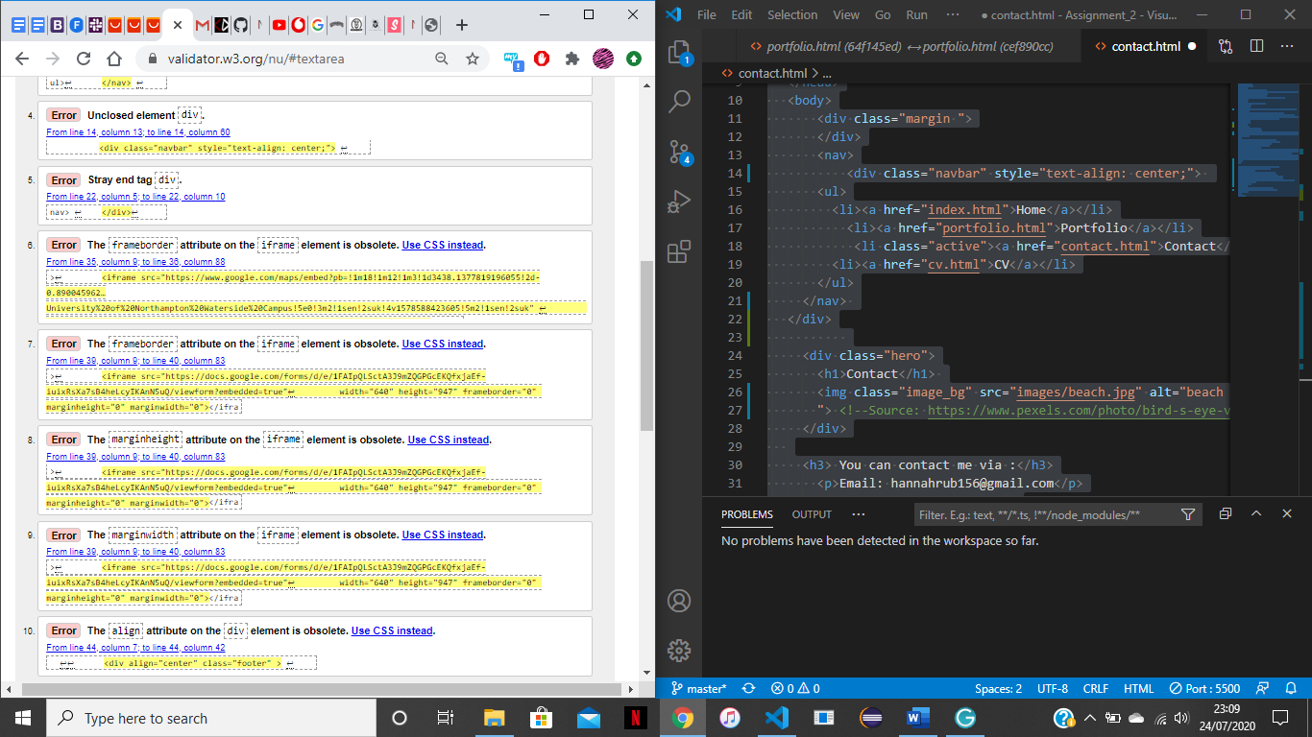

I did not make all the changes that where advices as it was causing issues with my site or when I go to check what was highlighted, I do not see the error. In this case it said I had a stranded div tag when I did not.

Style.css:

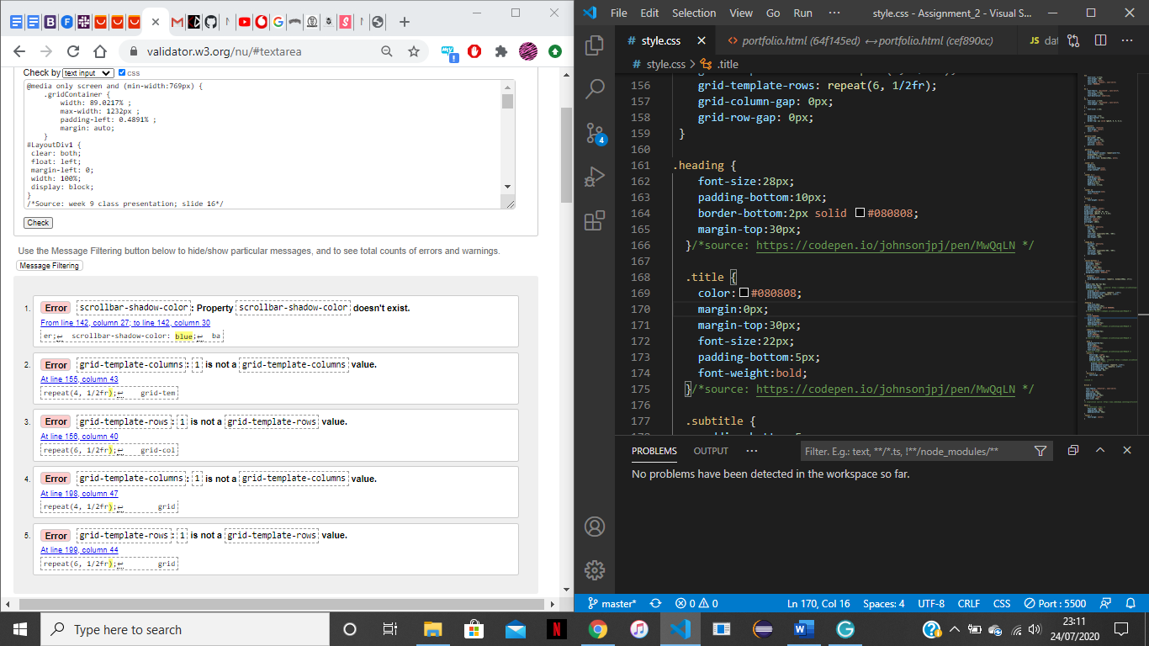

I did not make all the changes as when I did them it caused issues with the design of the site.

Clock.js

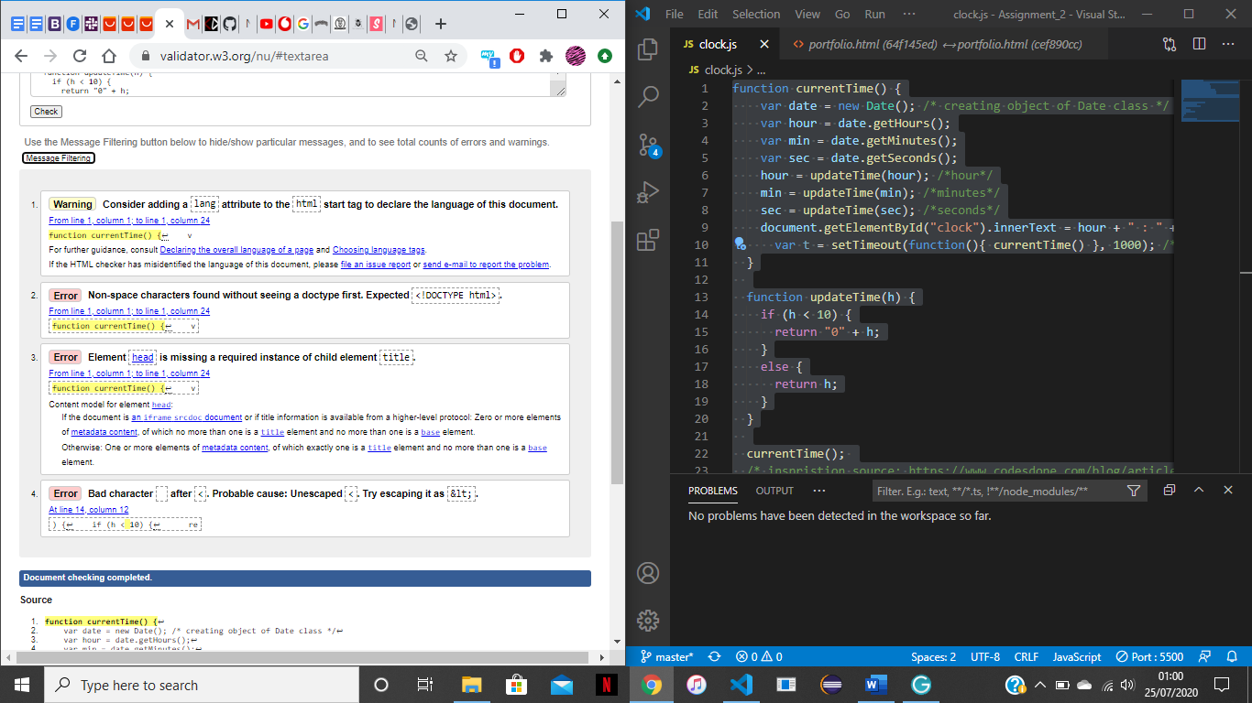

I did not make any changes as I did not understand what I was meant to change and I think that the code I entered was html instead of JavaScript.